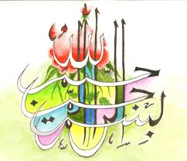
The Miracle Banana of Tuesday 22nd September 2015
The Exclusive Islamic Miracle Photographs of Dr Umar Elahi Azam
Tuesday 22nd September 2015
Manchester, UK
Introduction
On this banana, there were markings of unidentified Arabic. There was also a marking of The Name of Allah 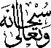 but three dots were missing, which I filled in with ball-point pen [ringed on the banana peel itself]. There was also a marking of the name of Muhammad 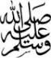 which I found by good fortune whilst I was using the lens of my Sony Xperia M2 Smartphone as a microscope to inspect other markings!
