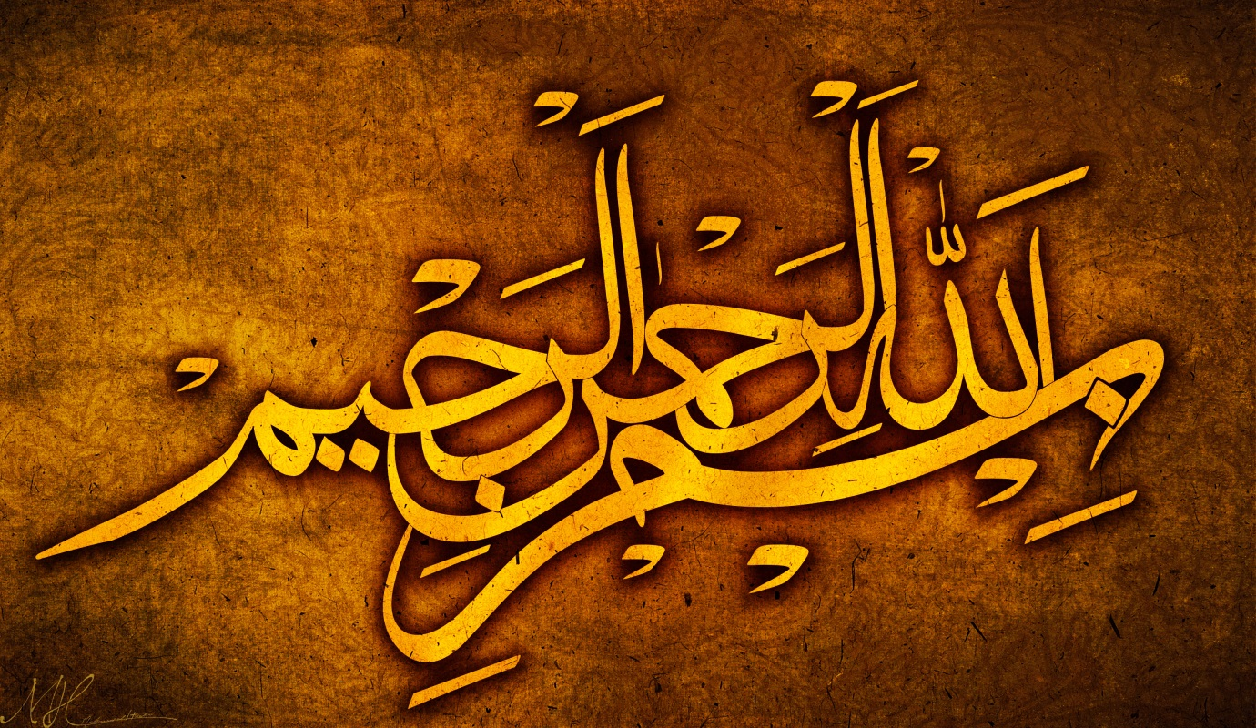
The Miracle Banana of Friday 11th September 2015
The Exclusive Islamic Miracle Photographs of Dr Umar Elahi Azam
Friday 11th September 2015
Manchester, UK

Introduction
Two markings of The Name of Allah 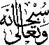 were found on the actual banana [not on the outer or inner peel but on the white flesh of the fruit itself]. I had just made myself a cup of coffee and something [Allah’s Insiration] told me to eat a banan – I felt like eating a banana even though the hot mug of coffee was awaiting me. I had already inspected the outer peel of the banana and there were no holy markings to be found. And I didn’t expect to see any inside either. Then, once again, Allah’s Inspiration was at work and I discovered two markings of the Holy Name on the banana.
