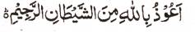

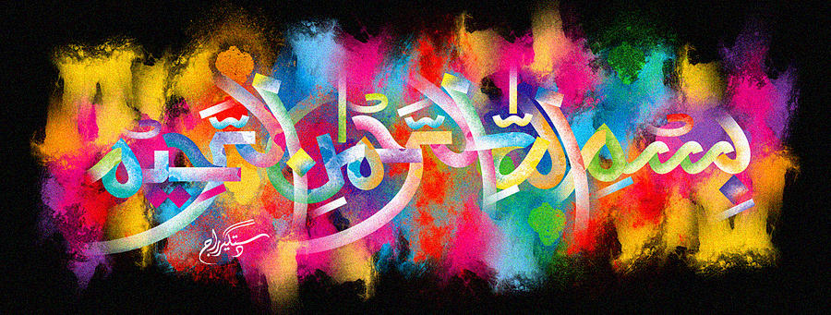
The Miracle Banana of 19th November 2015 – Vol 2
The Exclusive Islamic Miracle Photographs of Dr Umar Elahi Azam
^{Saturday} 28th November 2015
Manchester, UK

Introduction
This banana had 4 impressions of The Name of Allah 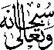 and 3 impressions of the Holy Name on a blemish.

