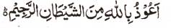

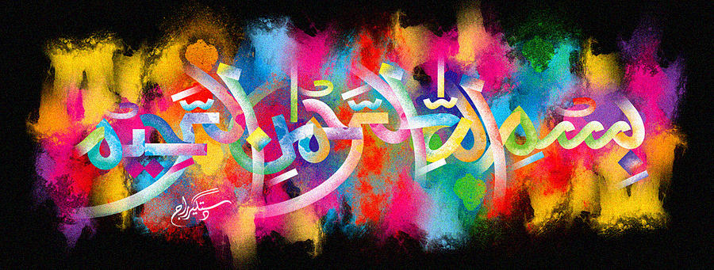
http://dr-umar-azam-islamicmiracles.weebly.com
Please see my Site, especially the RESEARCH section and sign my Guest Book with your unique comments.

The Miracle Banana of 17th January 2016
The Exclusive Islamic Miracle Photographs of Dr Umar Elahi Azam
Sunday 17th January 2016
Manchester, UK
Although these photographs belong to Dr Umar Azam, readers have permission to use any/all of the photographs as long as the source is acknowledged. Miracle Photographs, for example, have been shared on Twitter in the recent past.

Introduction
I was stuck in my work of producing Islamic Miracle Photograph files, so I was grateful to Allah when I saw the clear Name of Allah in the cross-section of this banana! The letter ‘aliph’ is to the far right, slanted and the letter ‘ha’ is sharp.
