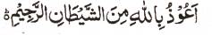

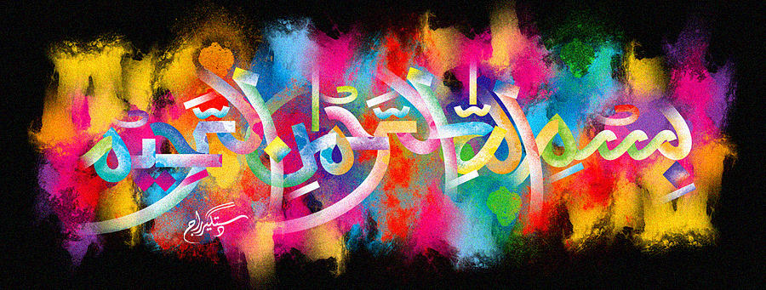
http://dr-umar-azam-islamicmiracles.weebly.com
Please see my Site, especially the RESEARCH section and sign my Guest Book with your unique comments.

The Miracle Banana of 14th January 2016
The Exclusive Islamic Miracle Photographs of Dr Umar Elahi Azam
Thursday 14 January 2016
Manchester, UK
Although these photographs belong to Dr Umar Azam, readers have permission to use any/all of the photographs as long as the source is acknowledged. Miracle Photographs, for example, have been shared on Twitter in the recent past.

Introduction
The ‘dal’ of Muhammad 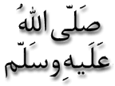 is very clear. The Name of Allah 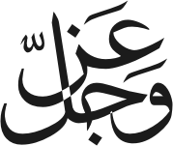 can be seen on the stem where the banana has been broken off the bunch, as well as around the area immediately below the stem.
