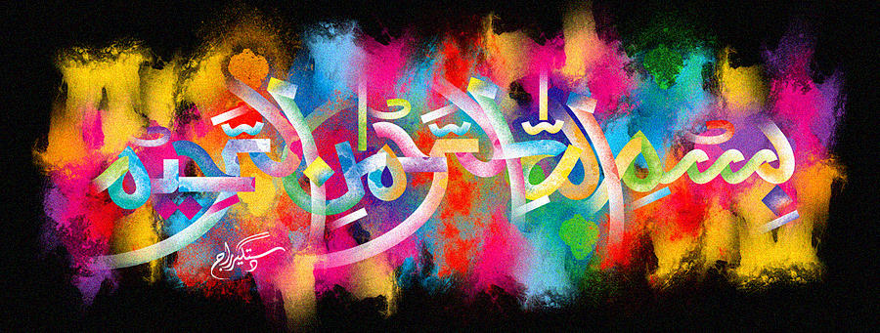
The Miracle Banana Crown
The Exclusive Islamic Miracle Photographs of Dr Umar Elahi Azam
Sunday 27th September 2015
Manchester, UK
Introduction
i experimented: i couldn’t find another marking of The Name of Allah 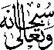 on the banana [the marking of which had already been photographed], so i broke off a roughly circular piece of the stem – and discovered the name of allah on the ‘crown’, plus a reverse, symmetrical imprint of the holy name on the actual piece broken off too! i concluded that it’s worth taking a risk – experimenting in an attempt to dicover hidden marking[s] in the fruit’s cross=section. it paid off in this case!
