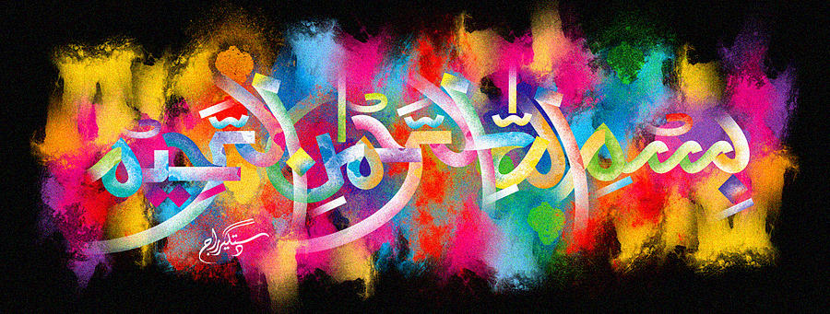
The Miracle Avocado Pear of 6th November 2015 – Vol 2

The Exclusive Islamic Miracle Photographs of Dr Umar Elahi Azam
Monday 9th November 2015
Manchester, UK

Introduction
There were 2 impressions of the Name of Allah 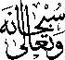 on the seed, 1 on the external surface and 1 on the internal surface, making a total of 4 impressions altogether.
