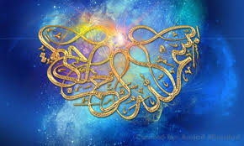
The Miracle Apricot Seeds of 3rd September 2015
The Exclusive Islamic Miracle Photographs of Dr Umar Elahi Azam
Tuesday 3rd September 2015
Manchester, UK

Introduction
The Name of Allah 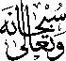 was on the surface of two apricot seeds belonging to a golden species of apricot bought, amongst other fruit and vegetables, from Manchester Superstores, Stockport Road, Manchester UK on Monday 31st August.
