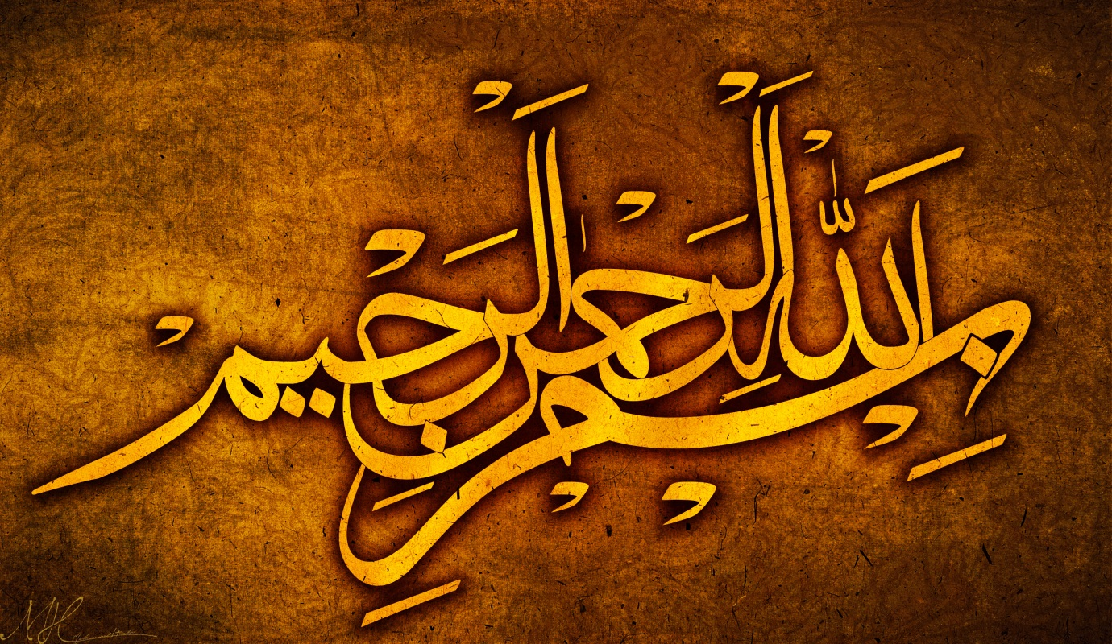
The Miracle Apple of Friday 11th September 2015
The Exclusive Islamic Miracle Photographs of Dr Umar Elahi Azam
Friday 11th September 2015
Manchester, UK

Introduction
The Name of Allah 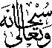 was found right in the centre of the apple.
