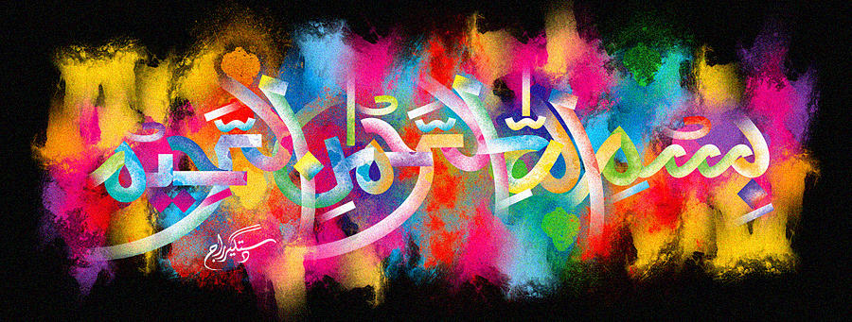
The Miracle Angeleno Red Plum of 9th October 2015
Vol 2
The Exclusive Islamic Miracle Photographs of Dr Umar Elahi Azam
Sunday 11th October 2015
Manchester, UK
Introduction
The Name of Allah was present on both halves of plum, and one impression of the Holy Name was in the cross-section besides the seed, making a total of 3 impressions.
