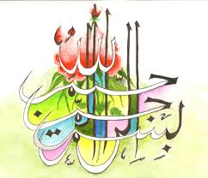
The Miracle Nectarines of Sunday 20th September 2015
Vol 3
The Exclusive Islamic Miracle Photographs of Dr Umar Elahi Azam
Sunday 20th September 2015
Manchester, UK
Introduction
Three markings of the Name of Allah 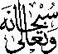 were on three seeds [stones] on these nectarines in the following sequence: 1st seed – one side; 2nd seed – both sides; 3rd seed – one side.
