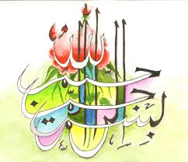

***T*he Miracle Nectarines of Sunday 20th September 2015**

**Vol 1**

***T*he Exclusive Islamic Miracle Photographs of Dr Umar Elahi Azam**

***S*unday 20th September 2015**

***M*anchester, UK**

**Introduction**

**Three markings of the Name of Allah**  **were on three seeds [stones] on these nectarines in the following sequence: 1st seed – one side; 2nd seed – both sides; 3rd seed – one side.**

PicturePicturePicturePicture

