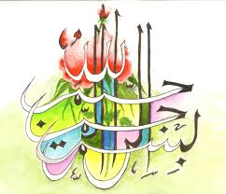
The Miracle Kiwi Fruit of Sunday 20th September 2015
The Exclusive Islamic Miracle Photographs of Dr Umar Elahi Azam
Sunday 20th September 2015
Manchester, UK
Introduction
The Name of Allah 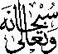 was found in two places in the same half of a kiwi fruit. The Holy Name was in the cross section of the kiwi fruit and was discovered by me by accident: that part of the peel of the kiwi fruit was unfurled by me accidentally or by Allah's Direction! Some of the seeds of that half also spelt the Name of Allah in Arabic.
