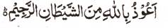

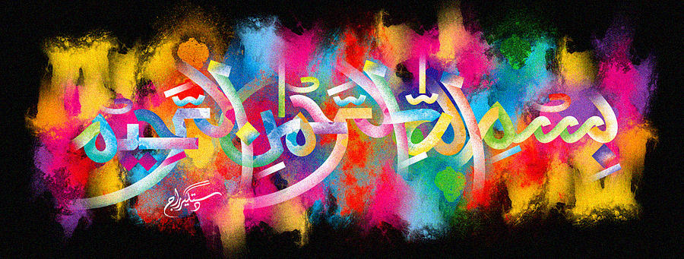
Spilt Cream on my Kitchen Worktop Naturally Forming The Name of Allah 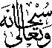
The Exclusive Islamic Miracle Photographs of Dr Umar Elahi Azam
^{Thursday} 17th December 2015
Manchester, UK

Introduction
The Name of Allah was naturally made by the spilt cream on the kitchen worktop of my Yarburgh Street, Manchester UK lodgings.
