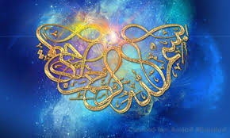
Allah’s Name on donut peaches
Vol. 2
The Exclusive Islamic Miracle Photographs of Dr Umar Elahi Azam
Wednesday 25 August 2015
Manchester, UK
Introduction
This Donut or Saturn species of peach had markings of the Name of Allah SWT both ouside and inside them.
