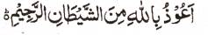

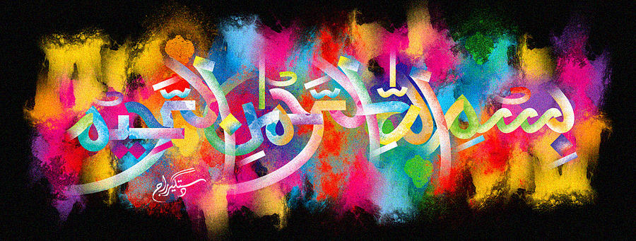
http://dr-umar-azam-islamicmiracles.weebly.com
Please see my Site, especially the RESEARCH section and sign my Guest Book with your unique comments.

A Part of the Name of Allah on a British Cox Pippin Apple
The Exclusive Islamic Miracle Photographs of Dr Umar Elahi Azam
^{Tuesday} 29th December 2015
Manchester, UK

Introduction
Unfortunately, I didn’t check the apple, biting into it straightaway and I had consumed the other part of the impression of the Holy Name before photography!
