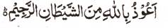

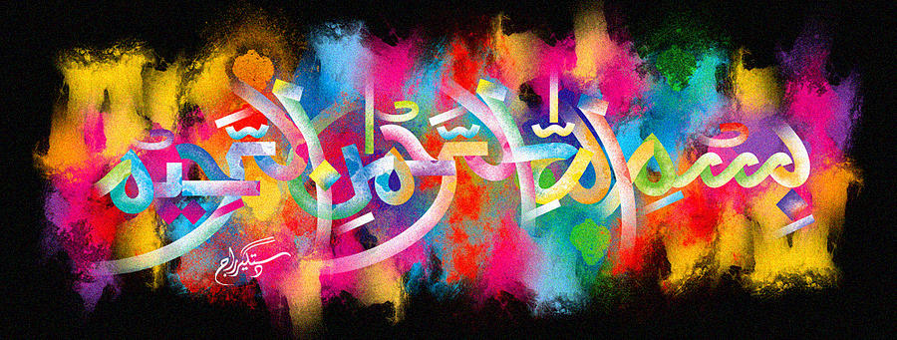
One More Impression of The Name of Allah 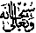 on the Halal Pizza of 26th December 2015
The Exclusive Islamic Miracle Photographs of Dr Umar Elahi Azam
^{Sunday} 27th December 2015
Manchester, UK

Introduction
This was a very large impression at the back of two joined slices of the pizza and, in fact, it is possible to decipher a second impression of the Holy Name [below the main one] if one looks carefully at the photographs.
