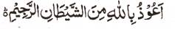

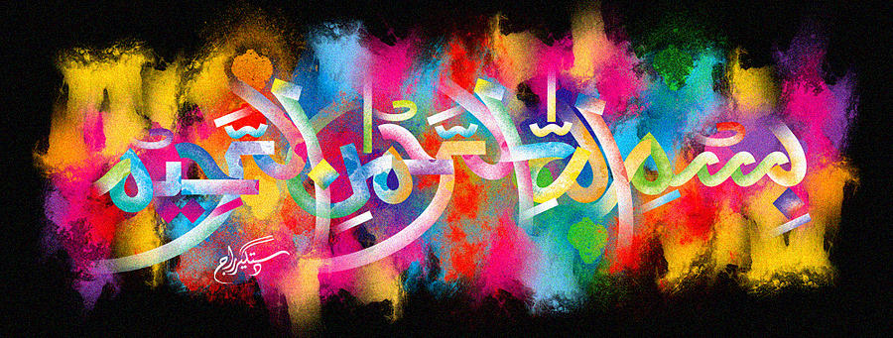
My Bite Marks Form the Name of Allah 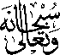 on the Inner Peel of a Brazilian Mango – Vol 2
The Exclusive Islamic Miracle Photographs of Dr Umar Elahi Azam
^{Wednesday} 25^{t} November 2015
Manchester, UK

Introduction
My bite indentations naturally formed The Name of Allah on the inner peel of a Brazilian mango.
