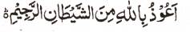

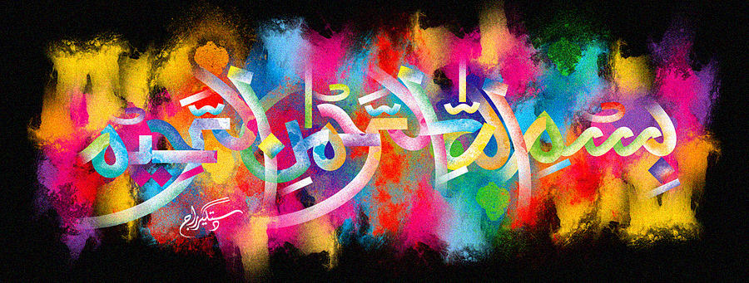
http://dr-umar-azam-islamicmiracles.weebly.com
Please see my Site, especially the RESEARCH section and sign my Guest Book with your unique comments.

MORE THAN ONE IMPRESSION OF the Name of Allah ON A MIGHTY FRESH MIXED CHEESE SANDWICH
The Exclusive Islamic Miracle Photographs of Dr Umar Elahi Azam
^{Thursday} 31st December 2015
Manchester, UK

Introduction
The impressions of The Name of Allah were fairly large and clear.
