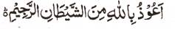

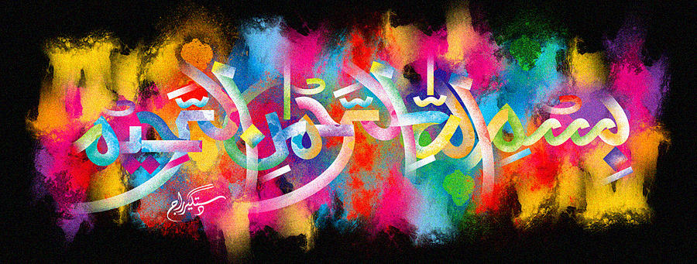
http://dr-umar-azam-islamicmiracles.weebly.com
Please see my Site, especially the RESEARCH section and sign my Guest Book with your unique comments.

MORE THAN ONE IMPRESSION of the Name of Allah in the Inner Cross-Section of A Coconut
The Exclusive Islamic Miracle Photographs of Dr Umar Elahi Azam
^{Thursday} 31st December 2015
Manchester, UK

Introduction
The impressions of The Name of Allah in the cross-section are fairly clear.
