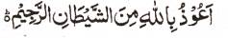

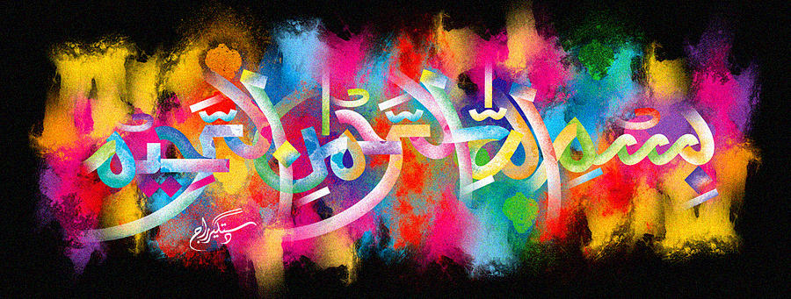
http://dr-umar-azam-islamicmiracles.weebly.com
Please see my Site, especially the RESEARCH section and sign my Guest Book with your unique comments.

The Name of Allah on the Inner Peel of a Kiwi Fruit and a Symmetrical Impression on the Fruit Itself – Vol 1
The Exclusive Islamic Miracle Photographs of Dr Umar Elahi Azam
Tuesday 5th January 2016
Manchester, UK
Although these photographs belong to Dr Umar Azam, readers have permission to use any/all of the photographs as long as the source is acknowledged. Miracle Photographs, for example, have been shared on Twitter in the recent past.

Introduction
Allah helped me with this miracle because I was ‘stuck’ with the work. I had already photographed the seeds of this kiwi fruit. But when I dissected the fruit for eating, a part of the kiwi fruit peel tailed off from the rest of the peel, revealing the Name of Allah on the inner peel and a symmetrical impression on the fruit itself.
