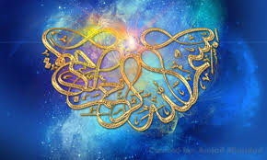
FOUR MARKINGS OF The NAME OF ALLAH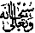 ON FOUR SMALL ORANGES
The Exclusive Islamic Miracle Photographs of Dr Umar Elahi Azam
Friday 28th August 2015
Manchester, UK

Introduction
There were 3 markings of the Name of Allah made by the minute Dotson their surfaces. An additional one marking was made by a natural blemish on the fourth orange. The three ‘dot’ markings were very difficult to find – they are invisible to the naked eye unless one has exceptionally good eyesight. I only found these three markings after using my Sony Xperia M2 Smatphone camera lens as a magnifying glass in artificial light at c. 5:30 am on 28th August. Photographing the three ‘dot’ oranges has been one of my most difficult encountered challenges yet when producing these Miracle Photographs Research files.
