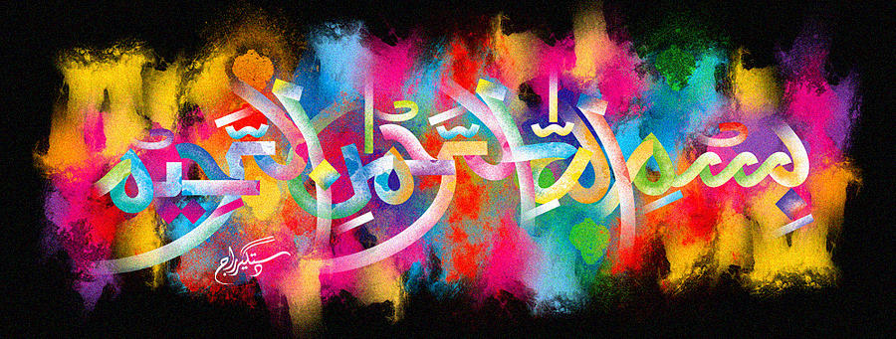
Four Impressions of the Name of Allah in the Cross-Section of a Cucumber

The Exclusive Islamic Miracle Photographs of Dr Umar Elahi Azam
Wednesday 14thOctober 2015
Islamic New Year Muharram 1437 A.H.
Manchester, UK
Introduction
The Name of Allah on the cucumber was seen by allowing light to fall on the cross-section and then looking for the shape of the Holy Name.
