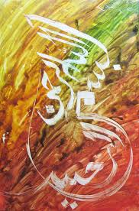
Conclusions Drawn from Dr Umar Elahi Azam’s Islamic Miracle Photographs
http://dr-umar-azam.weebly.com/research.html
Manchester, UK
Wednesday 9th September 2015

Introduction
There can be such phenomena as Islamic miracles in the contemporary period because it is stated in the Holy Quran that Allah will show man His Signs that the Quran – and therefore the religion of Islam – is the Truth:
41:52
to top
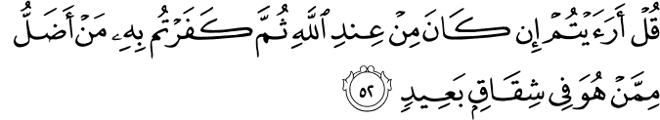
Sahih International
Say, "Have you considered: if the Qur'an is from Allah and you disbelieved in it, who would be more astray than one who is in extreme dissension?"
41:53
to top
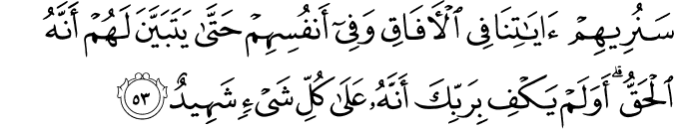
Sahih International
We will show them Our signs in the horizons and within themselves until it becomes clear to them that it is the truth. But is it not sufficient concerning your Lord that He is, over all things, a Witness?
http://quran.com/41
The Holy Quran does not give a time when such Signs will or will not be given. Therefore, contemporary miracles are possible. Fruits are significant because they are examples of the Bounties – or Favours – of Allah here on Earth:
6:99
to top
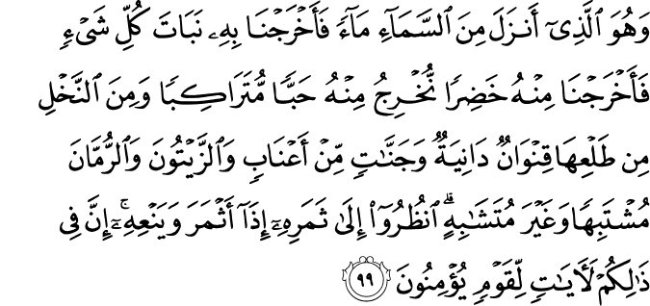
Sahih International
And it is He who sends down rain from the sky, and We produce thereby the growth of all things. We produce from it greenery from which We produce grains arranged in layers. And from the palm trees - of its emerging fruit are clusters hanging low. And [We produce] gardens of grapevines and olives and pomegranates, similar yet varied. Look at [each of] its fruit when it yields and [at] its ripening. Indeed in that are signs for a people who believe. http://quran.com/6

6:141
to top
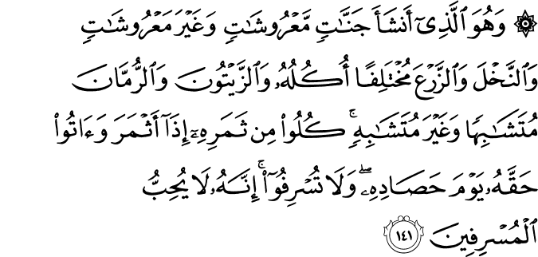
Sahih International
And He it is who causes gardens to grow, [both] trellised and untrellised, and palm trees and crops of different [kinds of] food and olives and pomegranates, similar and dissimilar. Eat of [each of] its fruit when it yields and give its due [zakah] on the day of its harvest. And be not excessive. Indeed, He does not like those who commit excess.
http://quran.com/6
Fruits are also significant because they will be a major, Eternal reward for the righteous in Paradise:
55:65
to top
Sahih International
So which of the favors of your Lord would you deny?
55:66
to top
Sahih International
In both of them are two springs, spouting.
55:67
to top
Sahih International
So which of the favors of your Lord would you deny?
55:68
to top
Sahih International
In both of them are fruit and palm trees and pomegranates.
http://quran.com/55

The Method of Research
I separated the checking of the fruit or other produce from the process of photography; for example, I separated five bananas from their bunch and looked at each one individually. When a holy marking of the Name of Allah SWT or that of Muhammad SAW was found, I took two or three photographs of each marking, changing the angle here and there. I also moved the fruit further away from my smartphone camera lens, or closer, depending on whether the image is burred or sharp. Having taken the photograph of one marking, I turned the smartphone back to standby mode, examined the next fruit and repeated the process. If plenty of markings were found, I made a table and jotted down the fruit number and what particular markingswere found, abbreviating the Name of Allah SWT to ‘A’ and the name of Muhammad SAW to ‘M’; if both were together on the same fruit I recorded the markings as ‘A-M’:
For example [and this is a hypothetical example, not actual findings]:

Please scroll down for the table >>>>>

Banana No. |  |  |  | Markinging |  |  |  |  | g
 | 1. |  |  | A
2. |  |  |  | M
3. |  |  |  | A, A, M
4. |  |  |  | A-M |  | , UAr
5. |  |  |  | M, M

So, in the table above, M, M would mean that 2 markings of the name of Muhammad SAW were found on the same banana. UAr means: ‘Unidentified Arabic’. Then I emailed the photographs in batches of 9 from my photos album on my Sony Xperia M2 Smartphone to my Gmail address [if more than 9 photographs are sent a message informs me that the amount of kb has been exceeded and that one or more of the photographs will not be sent]. In the case of my Paper of 18/8/15, I had 36 photographs to send, so I sent 4 batches of 9 to my email account. In the ‘subject’ line of the email, I entered ‘Bananas 1’[meaning the first batch of 9] and in the main body of the email, I just typed: ‘Here.’ Then, when I wanted to upload the photographs onto my Islamic Miracles Website: http://dr-umar-azam-islamicmiracles.weebly.com/research.html , I opened my Gmail account and downloaded the first batch of 9 onto the ‘Pictures’ folder of the computer memory storage. Then I logged onto the control panel of my Weebly Website and uploaded the photographs from that ‘Pictures’folder to each ‘Image’ icon in my Website Editor. So that I didn’t get confused after I had prepared one Paper, I deleted the photographs from the ‘Pictures’ folder before uploading the next set.
The following sequence is the action to take to delete the photographs stored in that folder:

Organise > Select all > Organise> Delete> |  |  | Pop-
up confirmation: Are you sure you want to delete all selected? | > Yes

For multiple Papers, I have the first MSWord document that acts as a template or default draft for all subsequent Papers for that evening. I can change the fonts, colours, sizes of the fonts to offer variety in the format of the Papers. I copy and paste the title, author, date and introduction, as well as the colour separator lines, onto a new MS Word document and delete the default version.
After I had finished this second paper, it would serve as the default one until it was deleted when I begin the third Paper and its new introduction and photographs… and so forth for the Papers to be produced that evening. I then converted the MS Word file to a PDF using an online conversion Site such as www.go4convert.com [it is excellent because there is no limit to the size of the file; this Ihave found invaluable because photographs take up a great deal of kilo bytes]. I stored at least one MS Word file in my email account or Website because the PDF can’t be edited and so serve as the default: it has to be an MS Word file. After the PDF became available, it was this file that I uploaded onto my Website via the Site Editor ‘Files’ icon. I copied and pasted, for example, [Miracle Photographs Research File] MRF No 101 for the next file – MRF No 102- but just changed one digit – the ‘1’ into a ‘2’ to save myself having to type out the whole title again. But I found that I had to reduce the size of the font and fill in the colour every single time for each new Paper because size and colour options are not default –the default settings are the Site Editor settings. Below are examples of some of my rough drafts of research Papers:
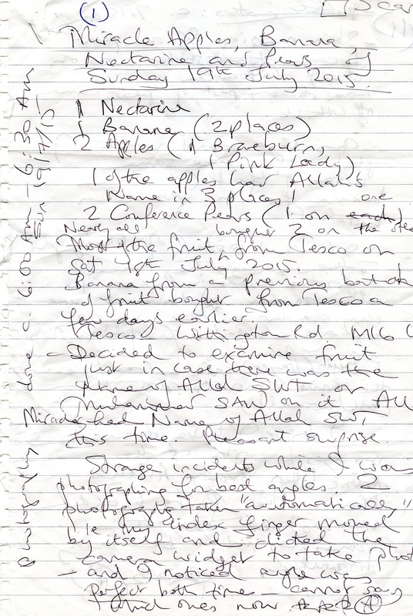
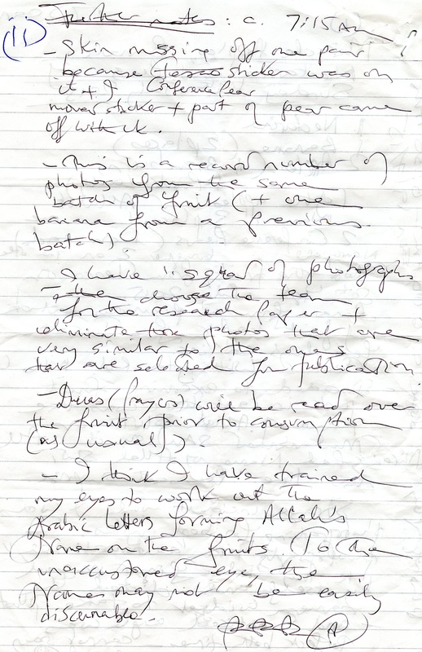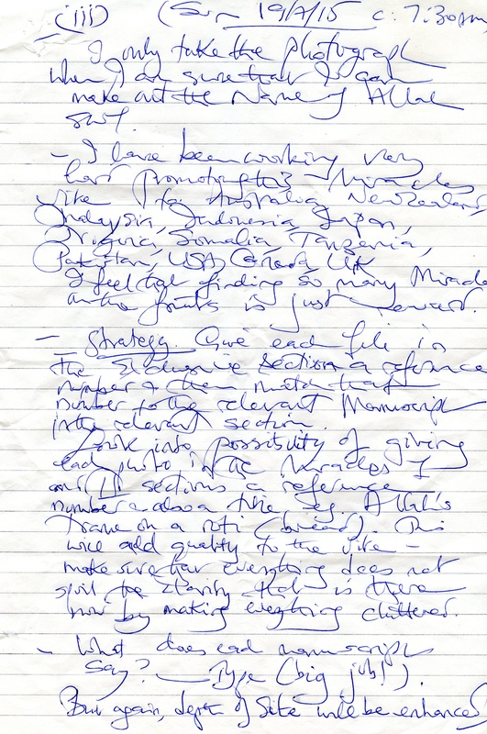
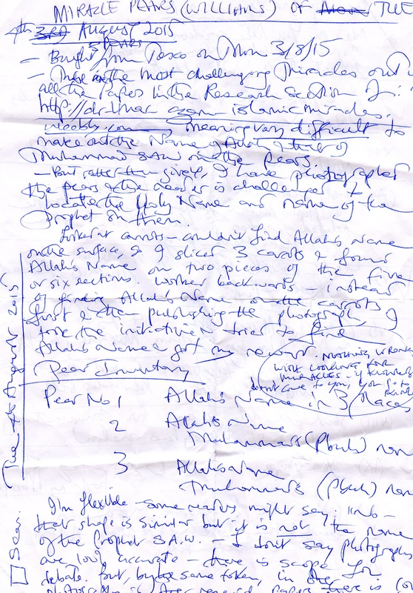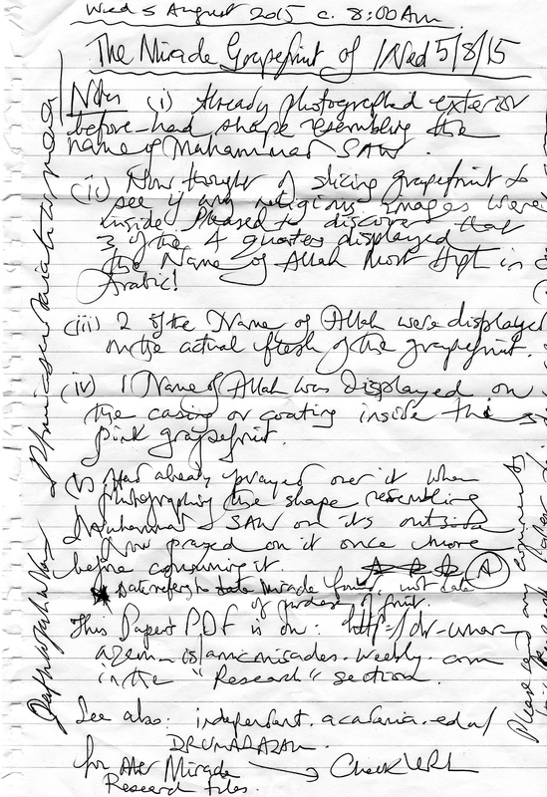

The Findings
My research is a further development to the splendid photography and video recordings of others who have discovered miracles not just on produce but made by trees; on animals; cries of the Name of Allah sounded by animals; in the sky; in the oceans; on mountains and so forth. A Google search of ‘Islamic Miracles’ then ‘Images’ will reveal plenty of examples. I feel, however, that the intensity of my research into fruits and vegetables specifically may be a n acceleration of a pioneering and serious academic study of Islamic miracles.
My research is on natural produce because the items were near to hand. I didn’t have to venture into the wider world –forests, for example – to study them. Many fruits and vegetables – bought for personal consumption - were photographed when miracles were discovered on them [and this is not an exhaustive list]:
Granny Smith Apple | Royal Gala Apple | Golden Delicious  Apple | Banana | Tomato
Cucumber | Cantaloupe Melon | Honeydew Melon | Galia Melon | Minneola
Williams Pear | Packham Pear | Pomegranate | Orange | Tangerine
Satsuma | Khaki Fruit | Mooli [White Radish] | Grapefruit | Peach
Saturn [Donut] Peach | Carrot | Coconut | Cauliflower | Broccoli
Lime | Onion | Chilli | Kiwi Fruit
Strawberry | Mango | Dried Apricot | Guava

Miracles were found on the outer and inner peel of produce [bananas, for example]; on seeds [kiwi fruit] and stones [plum]; on leaves [cauliflower]; deep inside, in the cross-section of the fruit [apricot] and made by the pith of the fruit [pomegranate].
There can be assorted and confusing shapes on the surface and interior of produce. The miracles are often present in item but the eyes have to be trained to spot the Arabic lettering. In fact, there can be as many as five holy markings on a single fruit [banana, cantaloupe melon]. There is a need to be alert when deciphering accurately the Name of Allah SWTand Muhammad SAW. In the case of the Name of Allah, for example, the Arabic letter ‘Aliph’ is at times separated from the rest of the Holy Name [the double ‘Lam’ and ‘Ha’]. There is also an element of mystery: unidentified Arabic markings have been discovered on bananas and it is highly unlikely if anyone will be able to make sense of them when seeing the photographs. However, they probably do have some significance; the Knowledge of Allah is infinite but man’s comprehension has limitations. Some markings are small – even tiny - as on dried apricots, whereas others are emphatic, as quickly observed by the naked eye – and at a distance – for example, inside a tomato.
My Islamic Miracle Photographs have identified some of Allah’s Signs on fruits [and other produce] here on Earth. The Name of Allah and the name of Muhammad have both been found on fruits and other produce. Nature itself endorses Islam – out of all the hundreds of religions and beliefs – as the correct religion. The veracity of the Prophet-hood of Muhammad is confirmed or why would this holy name – out of all the names of human beings -appear so frequently in so many instances of miracles? The belief in miracles is a measure of the strength of faith of a Muslim. Anyone suggesting, for example, that they are random shapes –despite the evidence of verses from the Holy Quran itself as above – must have a weak imaan [faith]. Just as some believe that the world came about of its own accord, others will believe that the markings just happened for no reason. The test of belief is to accept Allah Most High is the subject of actions – the Creator of creation!

