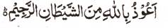

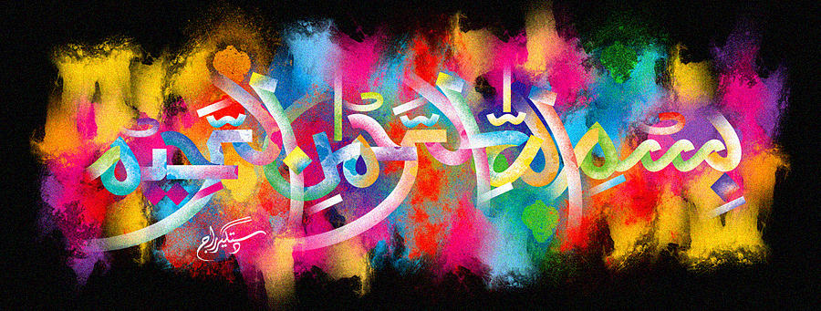
Another Marking of The Name of Muhammad 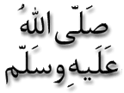 on the Second Miracle Pomegranate of 1-1-16
The Exclusive Islamic Miracle Photographs of Dr Umar Elahi Azam
^{Thursday} 7th January 2016
Manchester, UK

Introduction
The letter ‘mim’ is very clear at the top of the Prophet’s name.
