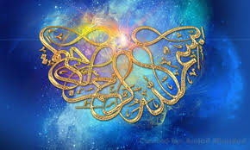
ALLAH’S 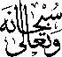 NAME
ON CARROTS
The Exclusive Islamic Miracle Photographs of Dr Umar Elahi Azam
Monday 1st September 2015
Manchester, UK

Introduction
The Name of Allah 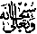 was on the side and at the end of two large carrots that were bought, amongst other fruit and vegetables, from Manchester Superstores, Stockport Road, Manchester UK on Monday 31st August.
