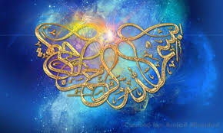
ALLAH’S 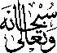 NAME IN 4 PLACES ON 2 KIWI FRUITS
The Exclusive Islamic Miracle Photographs of Dr Umar Elahi Azam
Saturday 29th August 2015
Manchester, UK

Introduction
The Name of Allah 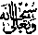 was formed by the seeds and pulp of the kiwi fruits, which were bought from Manchester Superstores, Stockport Road, Manchester UK on Monday 31st August.
