**Allah’s**  **Name in 2 Places in 2 Tangerines**

***T*he Exclusive Islamic Miracle Photographs of Dr Umar Elahi Azam**

***M*onday 24 August 2015**

***M*anchester, UK**

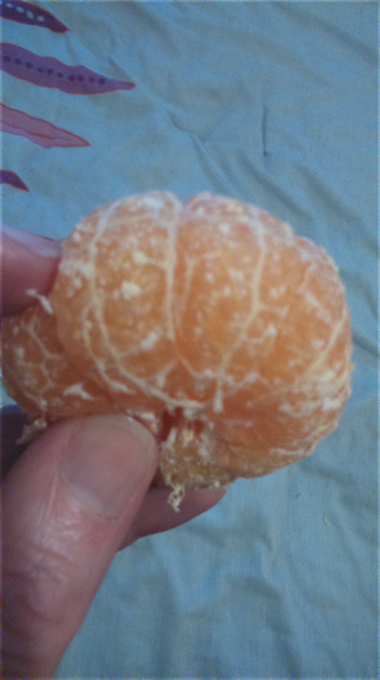 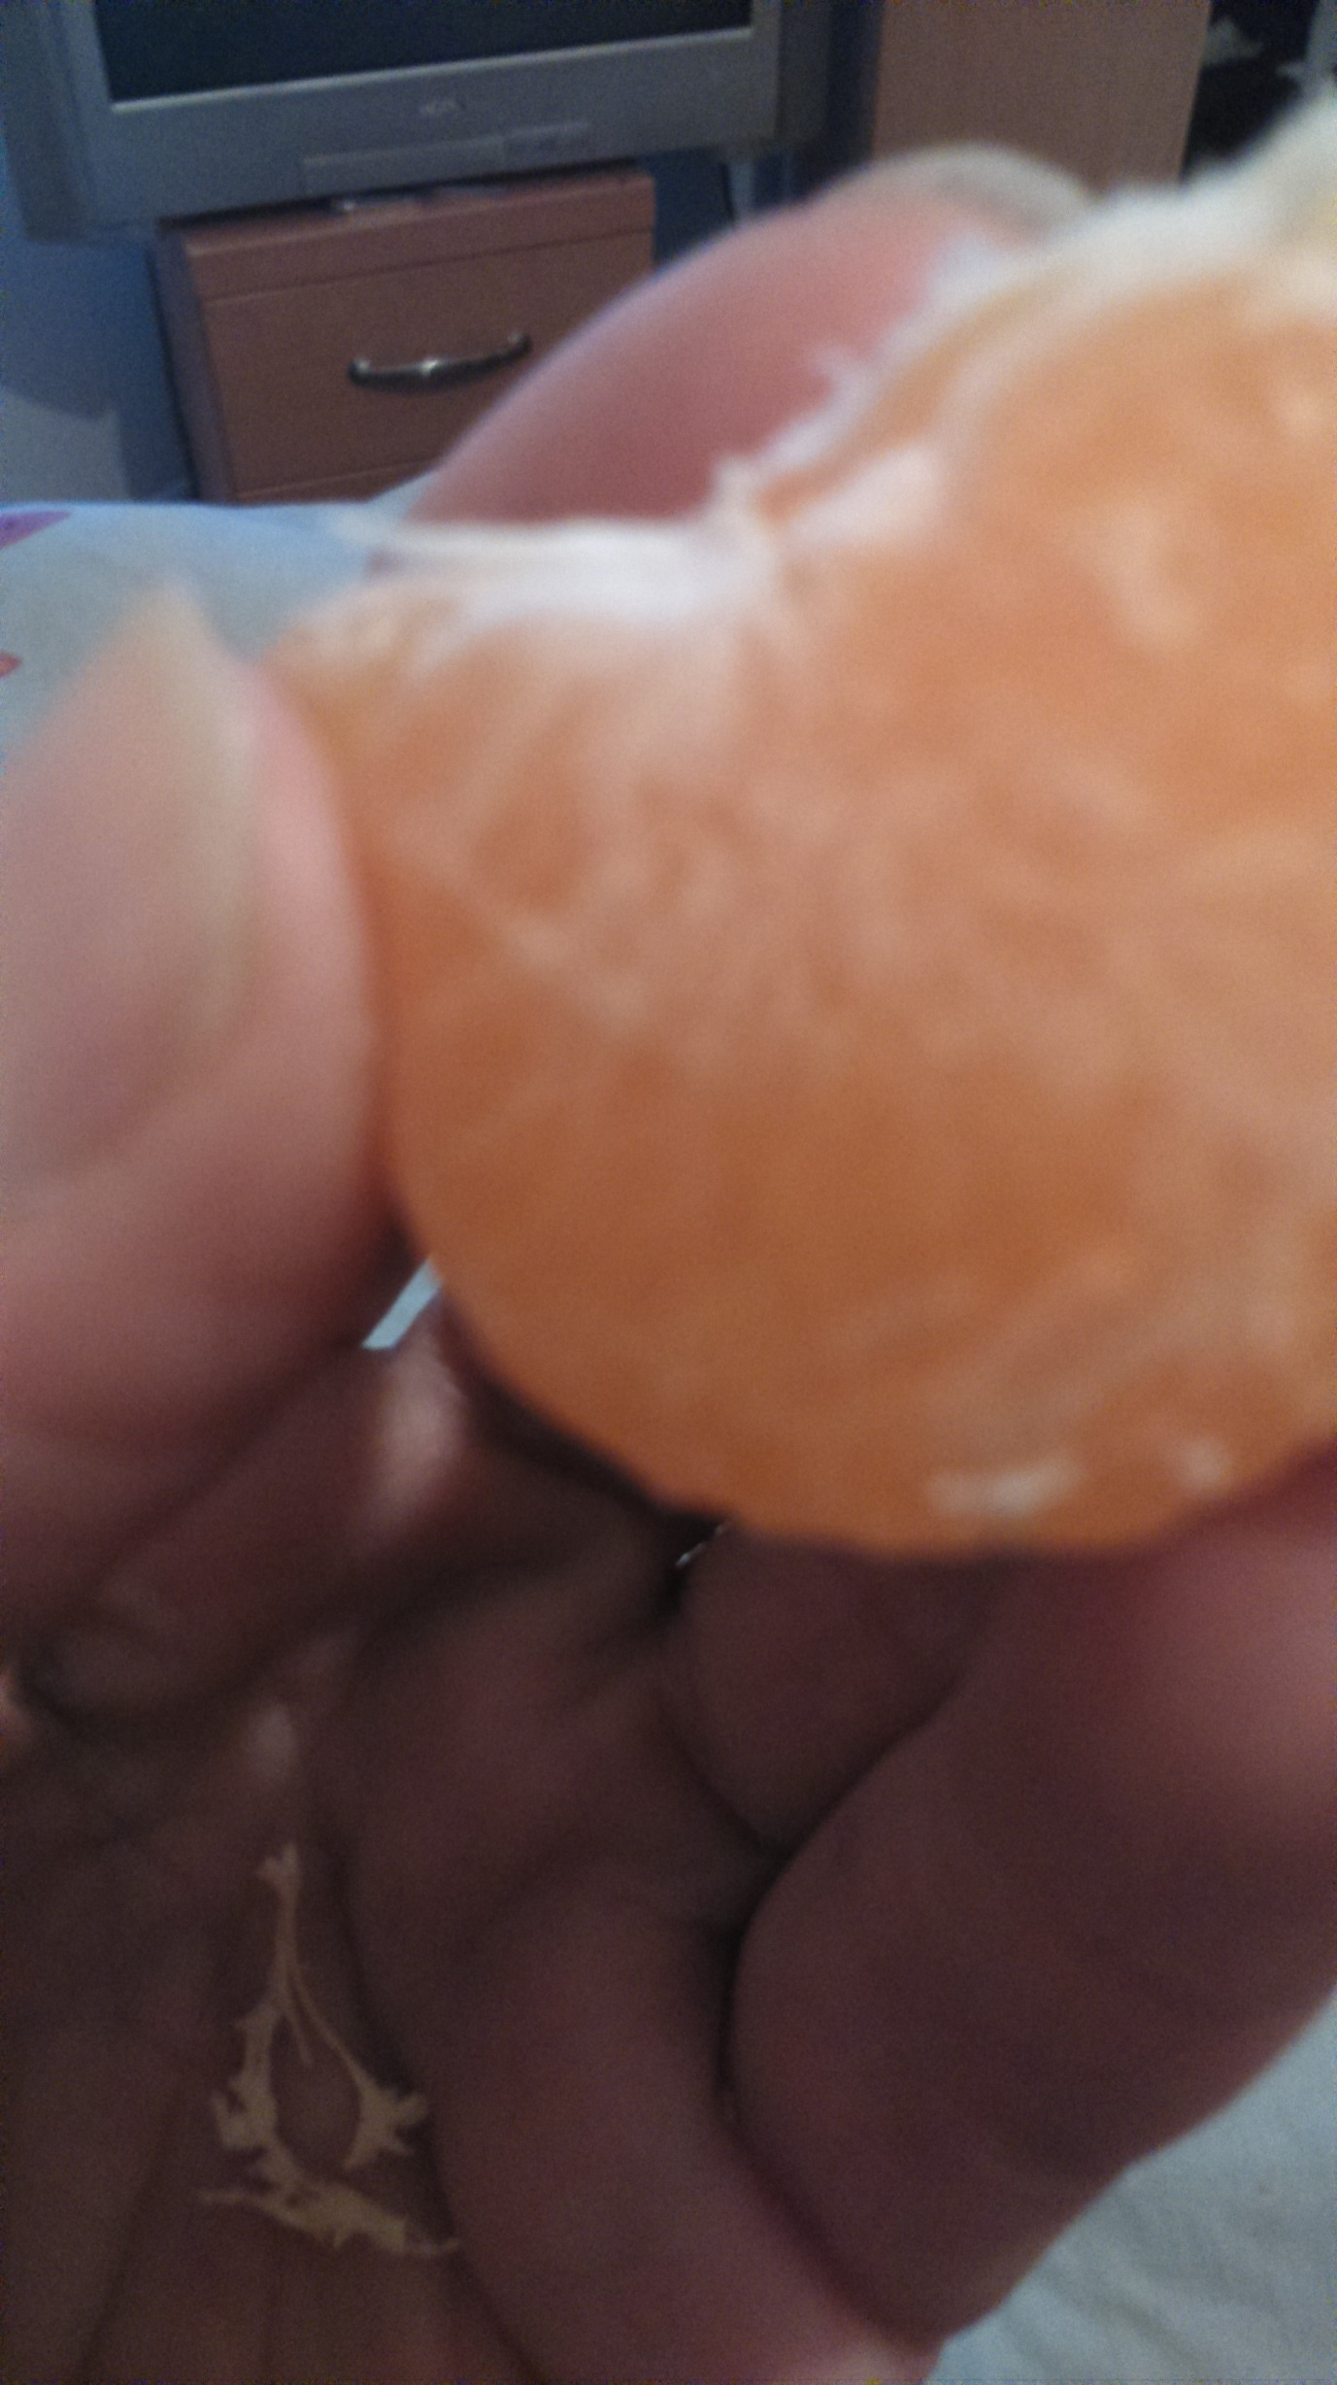 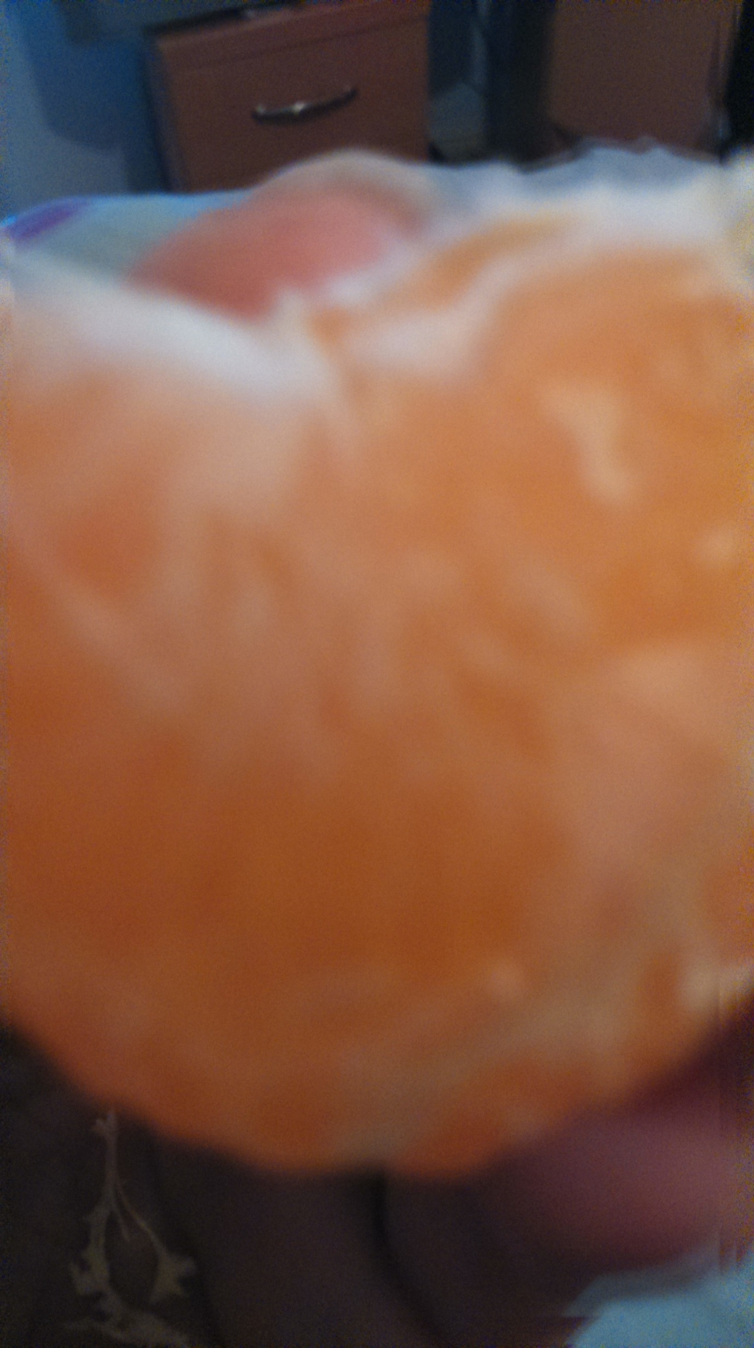 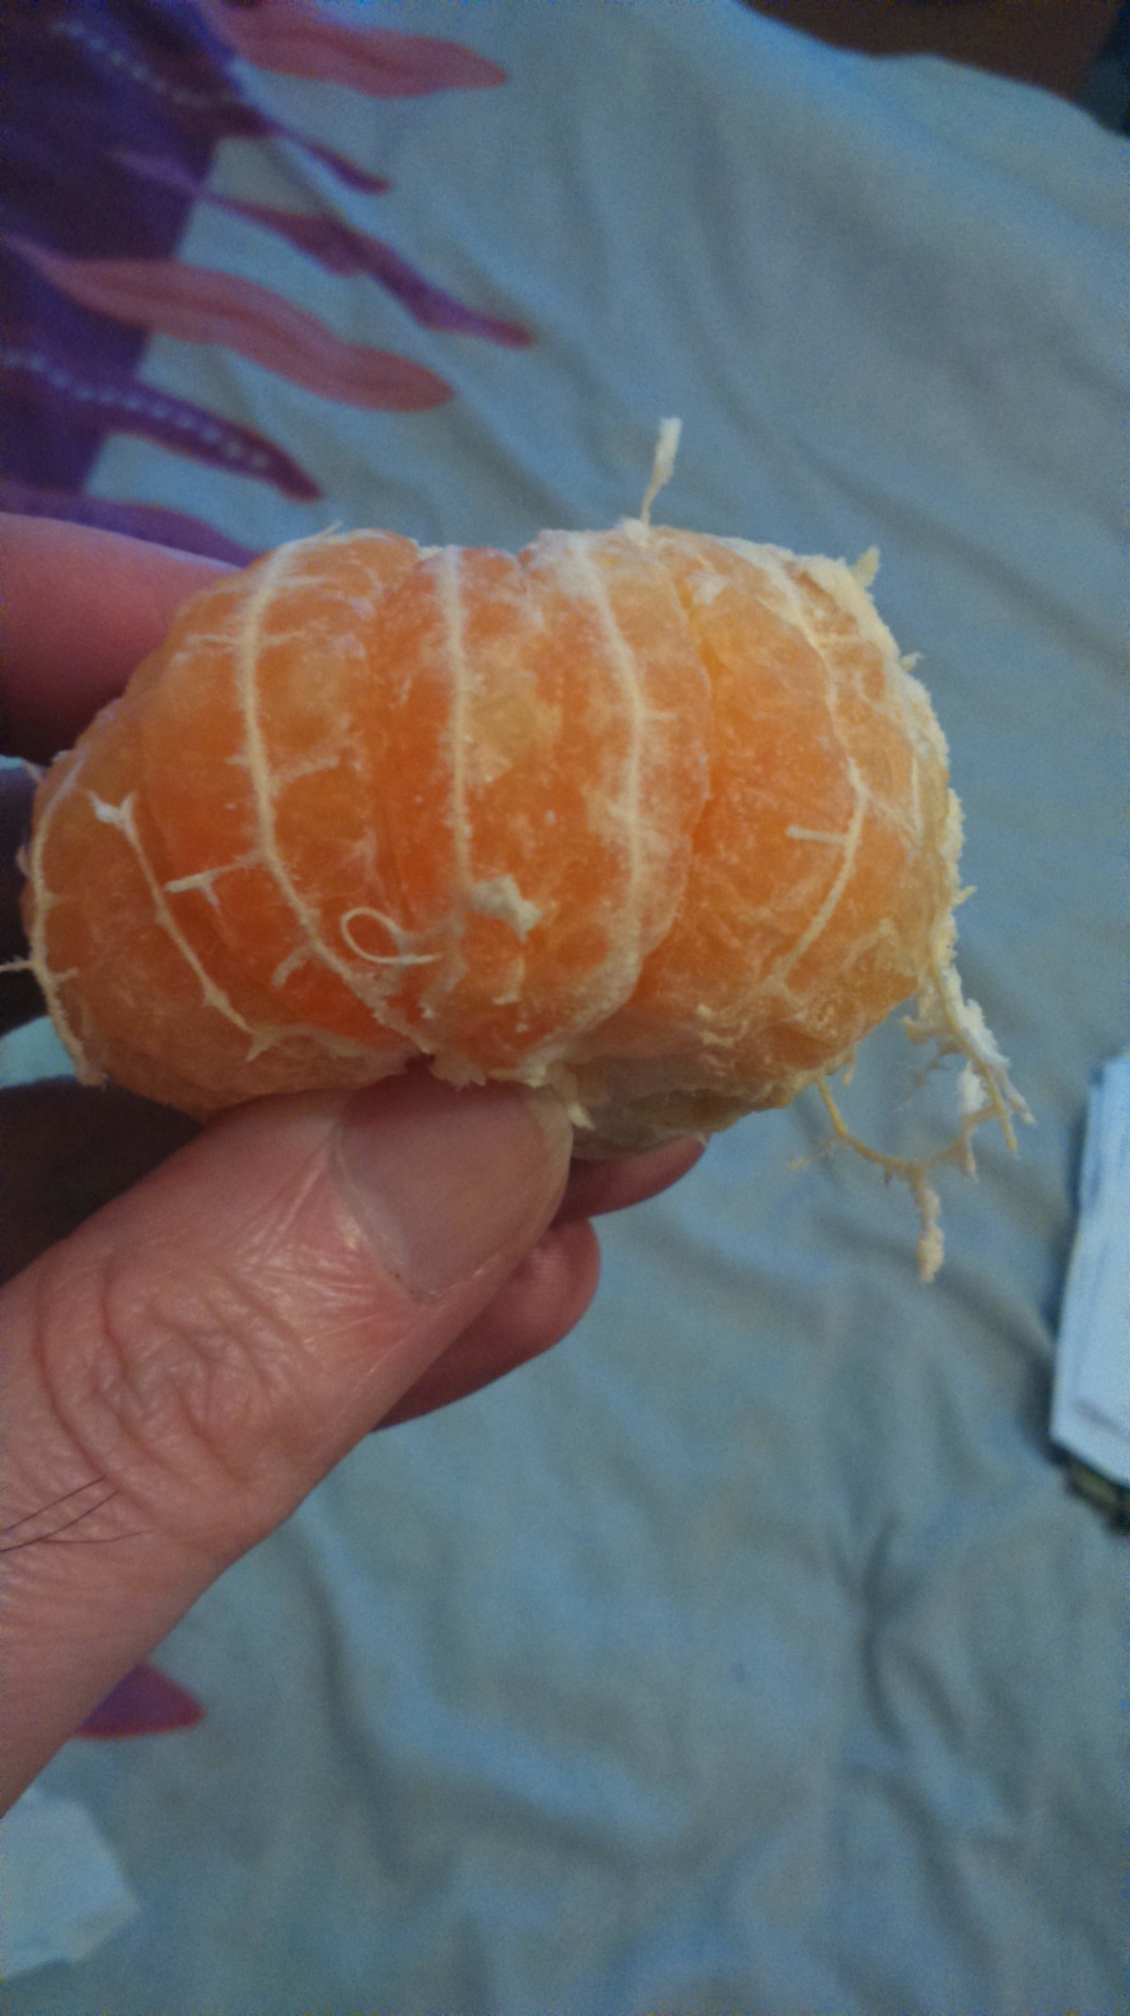 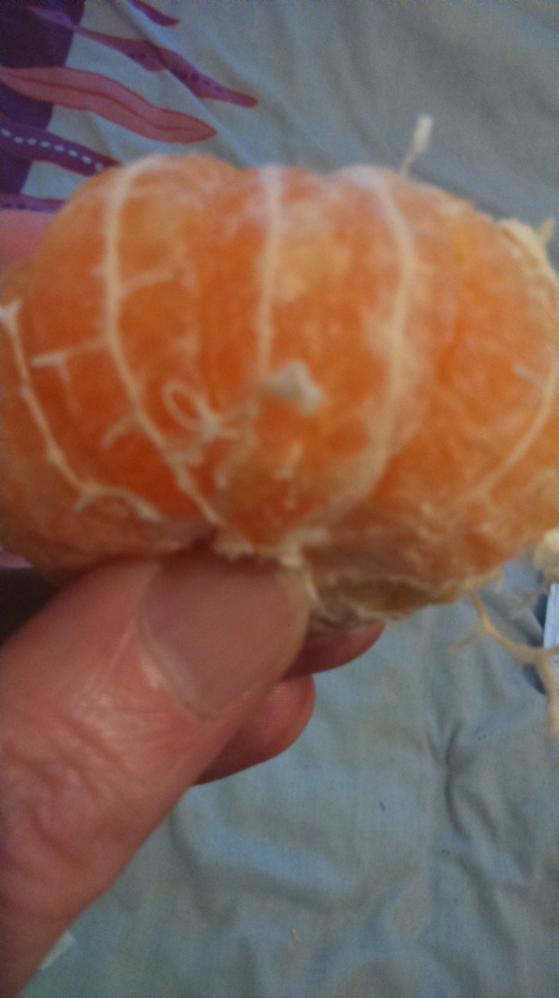 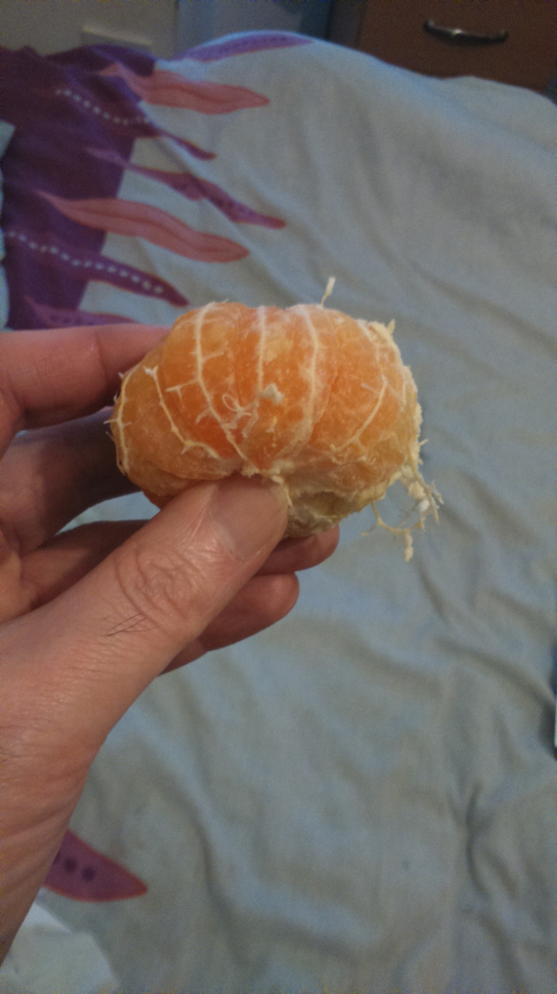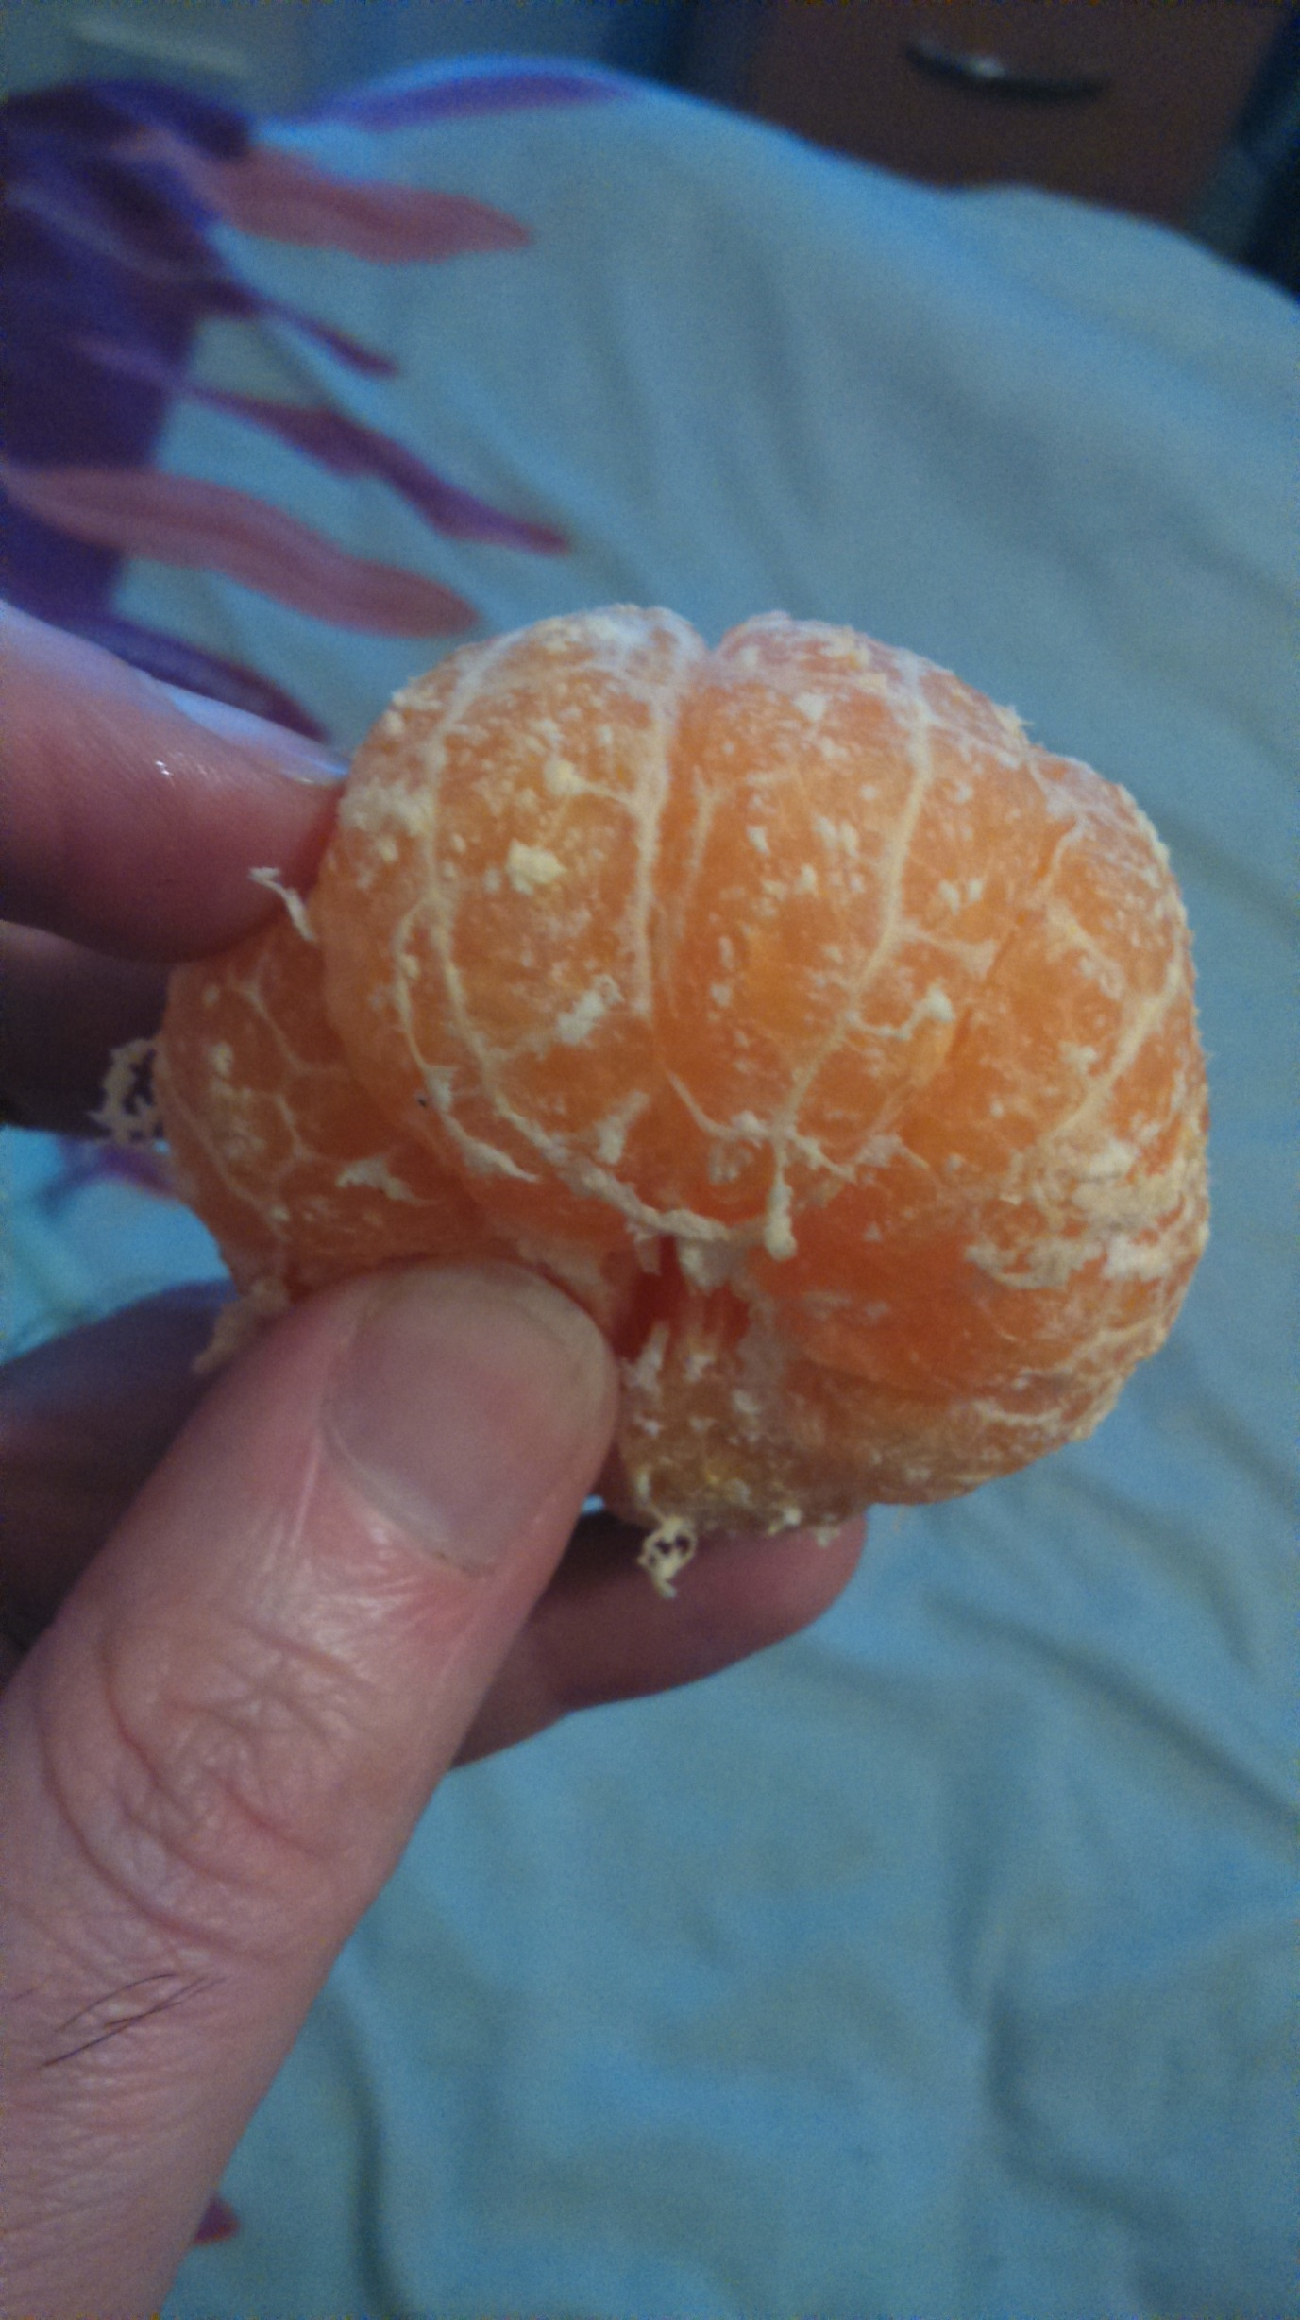

Picture Picture PicturePicture