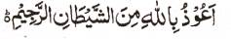

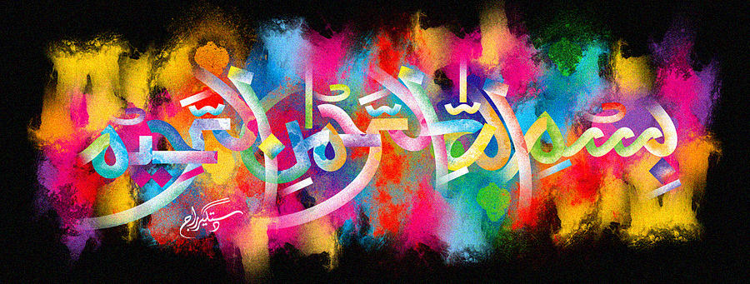
http://dr-umar-azam-islamicmiracles.weebly.com
Please see my Site, especially the RESEARCH section and sign my Guest Book with your unique comments.

A Very Large and Clear Impression of The Name of Allah on a Roti
The Exclusive Islamic Miracle Photographs of Dr Umar Elahi Azam
^{Tuesday} 29th December 2015
Manchester, UK

Introduction
A ‘roti’ is a chapatti and, in fact, a second impression of the Name of Allah can be seen to the above right of the main impression in one or two of the photographs below!
