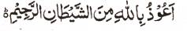

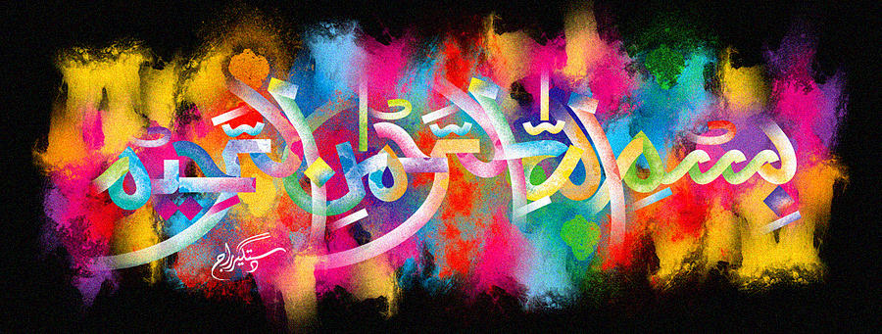
http://dr-umar-azam-islamicmiracles.weebly.com
Please see my Site, especially the RESEARCH section and sign my Guest Book with your unique comments.

A THIRD MIRACLE POMEGRANATE OF 18TH DECEMBER 2015 – VOL 2
The Exclusive Islamic Miracle Photographs of Dr Umar Elahi Azam
^{SUNDAY} 3 JANUARY 2016
Manchester, UK
Although these photographs belong to Dr Umar Azam, readers have permission to use any/all of the photographs as long as the source is acknowledged. Miracle Photographs, for example, have been shared on Twitter in the recent past.

Introduction
This pomegranate had three impressions of The Name of Allah on its outside surface and one of the impressions also seems to include the name of the Prophet Muhammad as well!
