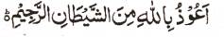

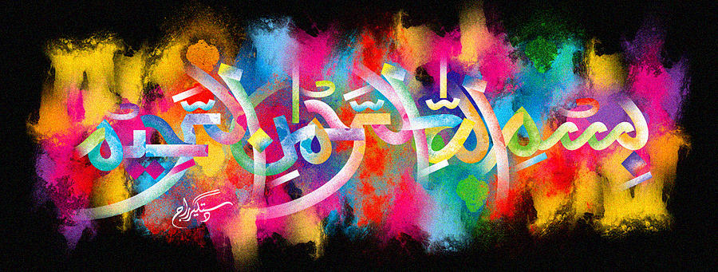
A Third Marking of the Name of Allah 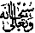on the Pomegranate of 1st January 2016
The Exclusive Islamic Miracle Photographs of Dr Umar Elahi Azam
^{Thursday} 7th January 2016
Manchester, UK

Introduction
The Holy Name was formed by a few of the fine lines arising from the stem of the pomegranate.
