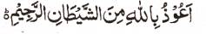

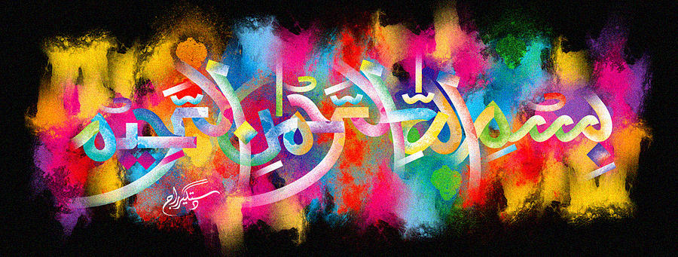
http://dr-umar-azam-islamicmiracles.weebly.com
Please see my Site, especially the RESEARCH section and sign my Guest Book with your unique comments.

A SECOND MIRACLE POMEGRANATE OF 18TH DECEMBER 2015
The Exclusive Islamic Miracle Photographs of Dr Umar Elahi Azam
^{SUNDAY} 3 JANUARY 2016
Manchester, UK
Although these photographs belong to Dr Umar Azam, readers have permission to use any/all of the photographs as long as the source is acknowledged. Miracle Photographs, for example, have been shared on Twitter in the recent past.

Introduction
There were a total of 4 impressions on the external surface of this pomegranate, three were impressions of The Name of Allah and there was one very large impression of the name of Muhammad
