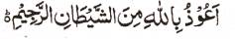

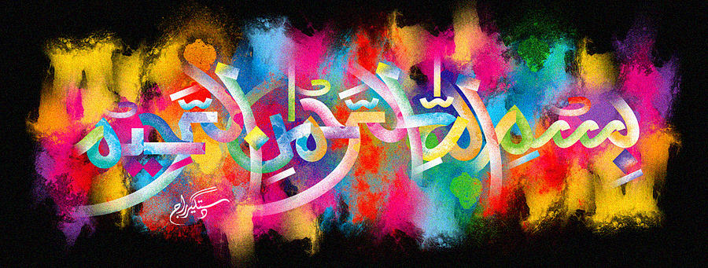
http://dr-umar-azam-islamicmiracles.weebly.com
Please see my Site, especially the RESEARCH section and sign my Guest Book with your unique comments.

A Miracle Onion
(29th December 2015)
The Exclusive Islamic Miracle Photographs of Dr Umar Elahi Azam
^{Tuesday} 29th December 2015
Manchester, UK

Introduction
There were 2 impressions of the Name of Allah on this onion: on the external surface and in the depths of the interior (more than one impression could be seen in the interior).
