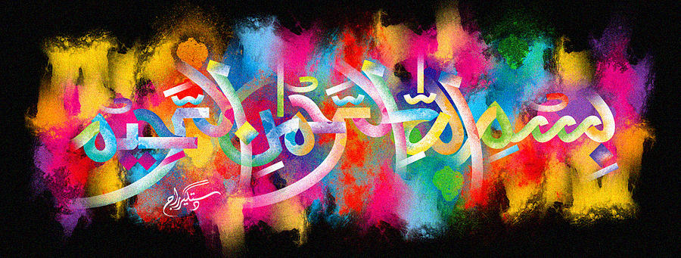
A Holy Seed from a Portuguese Angeleno Plum of 23rd October 2015
The Exclusive Islamic Miracle Photographs of Dr Umar Elahi Azam
Sunday 25th October 2015
Manchester, UK

Introduction
The Name of Allah clearly inscribed on the seed of this plum.
