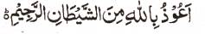

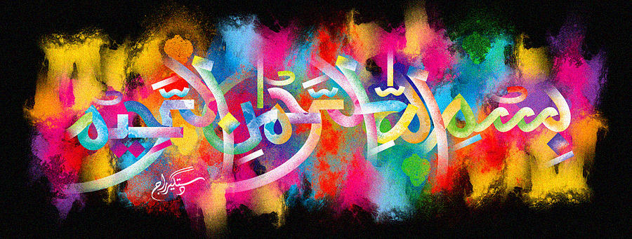
http://dr-umar-azam-islamicmiracles.weebly.com
Please see my Site, especially the RESEARCH section and sign my Guest Book with your unique comments.

A Double Double Impression of the Name of Allah on a Conference Pear – Vol 1
The Exclusive Islamic Miracle Photographs of Dr Umar Elahi Azam
Monday 4 January 2016
Manchester, UK
Although these photographs belong to Dr Umar Azam, readers have permission to use any/all of the photographs as long as the source is acknowledged. Miracle Photographs, for example, have been shared on Twitter in the recent past.

Introduction
This has never happened before!
