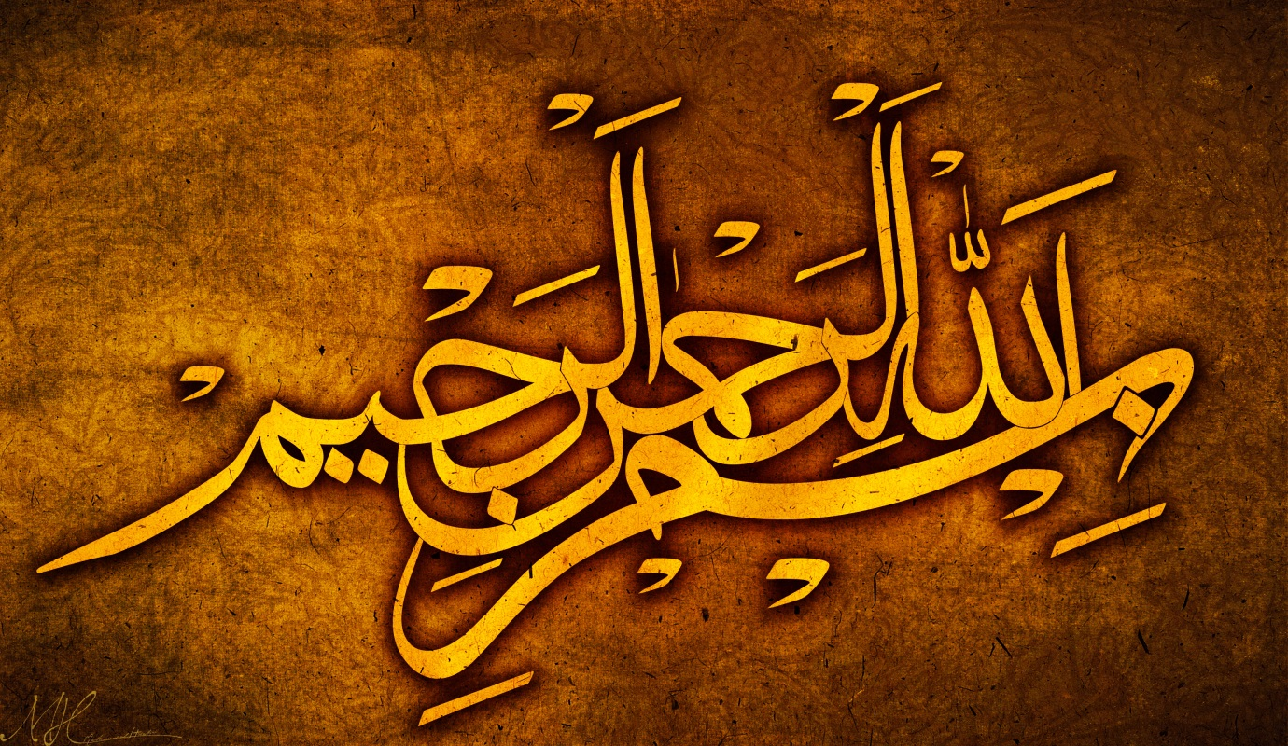
3 MARKINGS OF THE NAME OF ALLAH 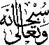 IN ARABIC ON THE SURFACE OF 2 GUAVAS
Vol 2
The Exclusive Islamic Miracle Photographs of Dr Umar Elahi Azam
Frisday 4th September 2015
Manchester, UK

Introduction
The Name of Allah in Arabic was found to be present three times on the outside surface of two guavas from an entire punnet, bought from Manchester Superstore, Stockport Road, Manchester UK on Friday 4 September 2015.
