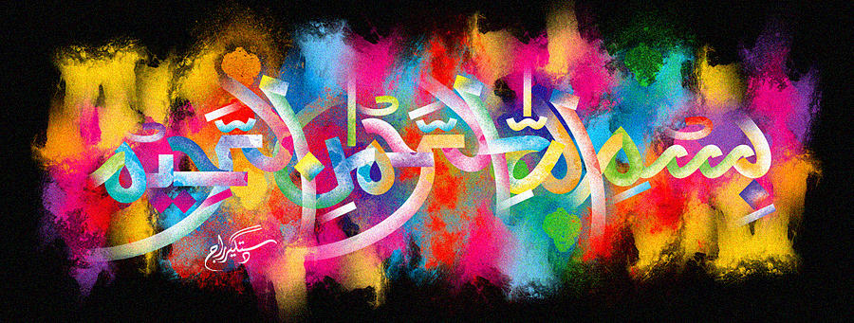
3 Impressions of the Name of Allah Ta’la on the Miracle Spanish Angeleno Plum of Friday 2nd October 2015
Vol 2
The Exclusive Islamic Miracle Photographs of Dr Umar Elahi Azam
Friday 2nd October 2015
Manchester, UK
Introduction
There was 1 large impression ofThe name of Allah on the exterior surface of the plum and 2 impressions of the Holy Name in the interior – the cross-section.

