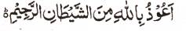

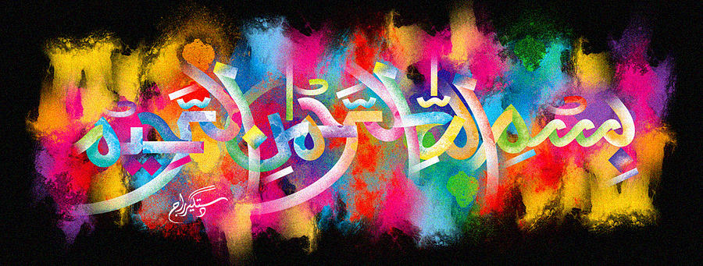
2 Impressions of The Name of Allah 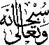 on 2 Morsels of Halal Fried Chicken
The Exclusive Islamic Miracle Photographs of Dr Umar Elahi Azam
^{Tuesday 17th} November 2015
Manchester, UK

Introduction
The piece of halal fried chicken was bought [along with chips, fish gravy and coleslaw] from my neighbour’s shop The Chicken Run on Yarburgh Street, Whalley Range, Manchester UK. There were 2 impressions of The Name of Allah on two morsels of the halal fried chicken!
