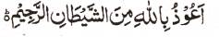

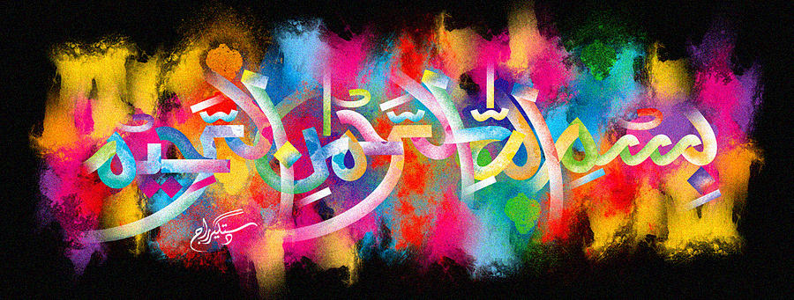
2 Impressions of The Name of Allah 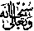 on the External Surface of a Pomegranate
The Exclusive Islamic Miracle Photographs of Dr Umar Elahi Azam
^{Thursday 24th} December 2015
Manchester, UK

Introduction
The two impressions of the Holy Name were unusually large and prominent!
