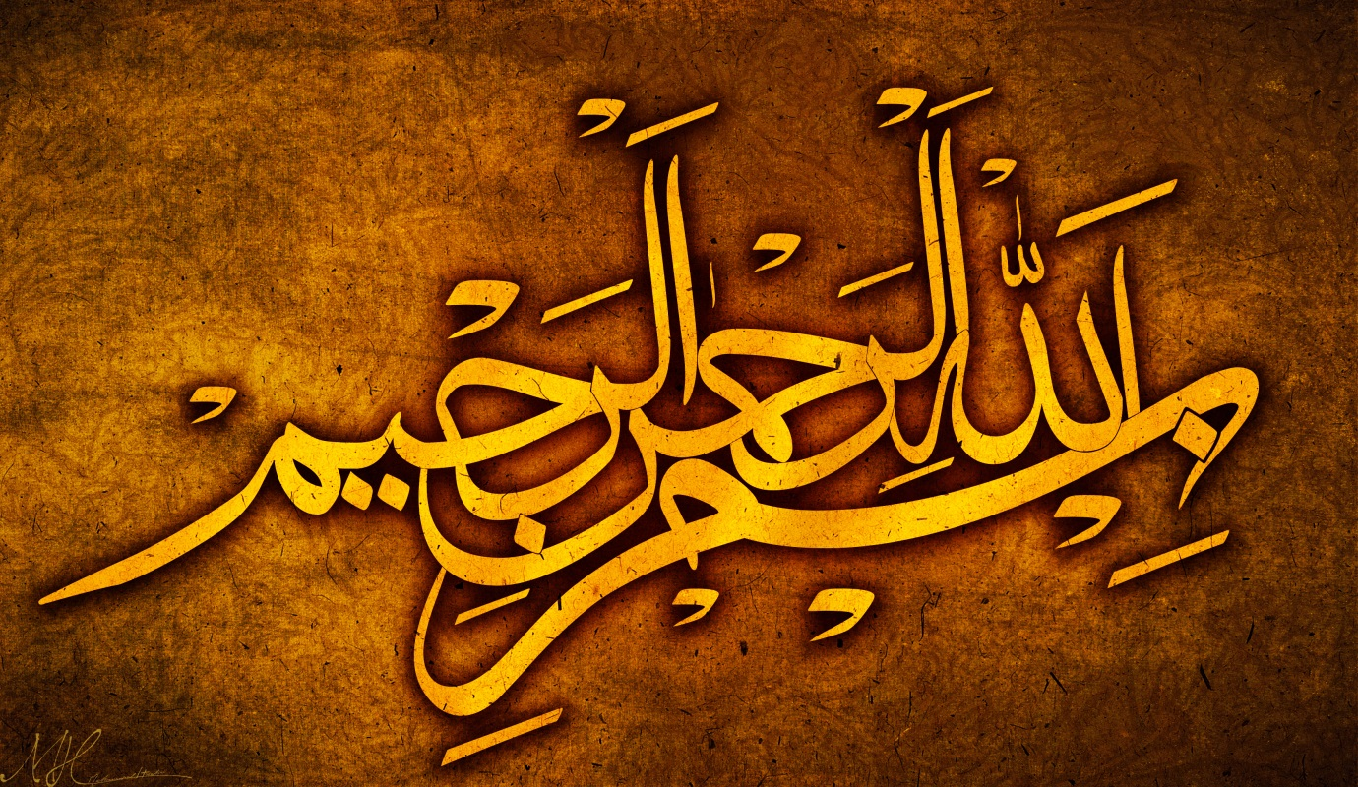
1O IMPRESSIONS OF THE NAME OFALLAH 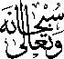 AND THE NAME OF MUHAMMAD (صلی اللہ علیہ وسلم) ON 3 WILLIAMS PEARS
Vol. 1
The Exclusive Islamic Miracle Photographs of Dr Umar Elahi Azam
Thursday 10th September 2015
Manchester, UK

Introduction
The Name of Allah and the name of Muhammad (صلی اللہ علیہ وسلم) in Arabic were found in the following way (A = Allah SWT; M = Muhammad SAW):
Pear No 1
M, A, A
The name of Muhammad SAW and Allah SWT side-by-side. The first time I have observed both Names so close together on a single fruit!
I turned the pear upside down and saw Allah’s Name again formed out of the first marking but the other way round! So there were ywo impressions of Allah’s Name on the same image! This is the first time such an incident has happened out of all the many fruits I have previously photographed!

Pear No 2
A, M A
Allah’s Name in wide, chunky marking. The name of Muhammad SAW in a clear, elongated form.The very small impression of the Name of Allah SWT.

Pear No 3
A, M, M, A
The Name of Allah SWT as a large, clear marking.
The Name of Muhammad SAW – 2 different markings.
The Name of Allah SWT as a very small marking.
