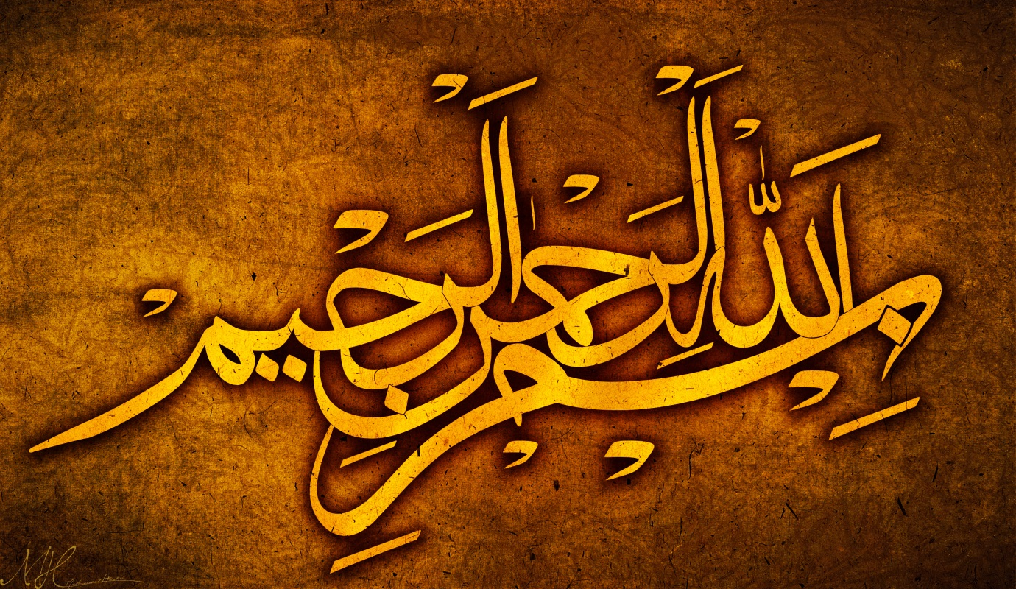
11 MARKINGS OF THE NAME OF ALLAH 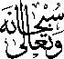 ON 5 BANANAS
Vol 4
The Exclusive Islamic Miracle Photographs of Dr Umar Elahi Azam
Monday 7th September 2015
Manchester, UK

Introduction
The bananas had the following markings:
BANANA |  | MARKING
1. | الله | الله
2. | الله | الله | UAr
3. | الله | الله
4. | الله | الله | الله
5. | الله | الله | UAr
UAr= | Unidentified | Arabic
